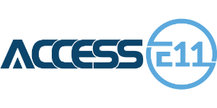

✅ Report Issues

✅ Track Progress

✅ Stay Informed

Your Voice Matters

A New Electronic Reporting Platform

123-456-7890 contact@municipality.com

www.municipalwebsite.com